Software Requirement Specifications
Student Grade Prediction System



Submitted by
Aiza Tanveer (S23BINFT1M01048)

Submitted to
Dr. Rana Nazir Ahmad

Department of Information Technology
Faculty of Computing
The Islamia University of Bahawalpur

Meeting Details
Sr No | Details | Date | Supervisor  Signature

Summary
This Software Requirements Specification (SRS) document describes the complete functional and non-functional requirements for the Student Grade Prediction System, a Final Year Project developed at the Islamia University of Bahawalpur, Department of Information Technology. The system applies machine learning algorithms, specifically Linear Regression and Decision Tree, to predict the academic grade of a student based on three core inputs: attendance percentage, weekly study hours, and previous examination marks. The document covers the system purpose, scope, product perspective, user characteristics, a literature review of similar systems, the proposed technology stack, seven functional requirements in standard format, non-functional requirements, six use cases with a system-level use case diagram, and activity diagrams for the main process flows. The system aims to support teachers in identifying at-risk students and to help students improve academic performance through early, data-driven feedback.

Table of Contents
1. Introduction 4
1.1. Purpose 4
1.2. Scope 4
1.3. Product Perspective 4
1.4. User Characteristics 4
1.5. Similar apps and systems/Literature Review 5
1.6. Proposed Technologies 5
2. Requirements 5
2.1. Function Requirements 5
2.1.1. User Registration 5
2.1.2. User Login 6
2.1.3. Enter Student Data 6
2.1.4. Grade Prediction 6
2.1.5. View Prediction Results 6
2.1.6. View Data Analytics 6
2.1.7. Manage Prediction Model 7
2.2. Non-Functional Requirements 7
3. Use Cases and Flow of Processes 7
3.1. Use Case 1 – Login / Register 8
3.2. Use Case 2 – Enter Student Data 8
3.3. Use Case 3 – Predict Grade 8
3.4. Use Case 4 – View Prediction Results 9
3.5. Use Case 5 – View Data Analytics 9
3.6. Use Case 6 – Manage Prediction Model 9
4. References 10

1. Introduction
The Student Grade Prediction System is a standalone, web-based academic tool developed for the Department of Information Technology at the Islamia University of Bahawalpur. The department offers undergraduate and postgraduate programmes in Information Technology and related computing disciplines, and serves several hundred active students each academic year. This system is designed to address a recurring challenge faced by faculty: identifying students who are at risk of academic underperformance before formal examinations take place. By analyzing routinely collected academic indicators such as class attendance, self-reported weekly study hours, and previous examination marks, the system applies supervised machine learning models to generate a predicted final grade for each student. The module being developed covers the full cycle from data entry through prediction display, and is intended to function as a complementary analytical tool alongside existing academic records.

1.1. Purpose
The primary purpose of the Student Grade Prediction System is to provide a simple, data-driven tool that assists educators and students in making informed academic decisions. The system is designed to predict student grades accurately using established machine learning algorithms trained on student performance data. It aims to help teachers identify weak-performing students early in the semester so that targeted support can be offered. At the same time, it enables students to understand how their current attendance and study habits are likely to affect their final grade, thereby motivating improvement. The system further evaluates and displays the accuracy of the prediction model in use, giving users confidence in the reliability of the results. Overall, the goal is to create a practical, efficient, and easy-to-use academic support tool that demonstrates the real-world application of basic machine learning concepts in the education sector.

1.2. Scope
The Student Grade Prediction System will include user authentication for students, teachers, and administrators; a student data input module for attendance percentage, weekly study hours, and previous marks; a grade prediction engine using Linear Regression and Decision Tree algorithms; a result display screen showing the predicted grade and model confidence; a data analytics dashboard for teachers and administrators; and a model management panel for the administrator to retrain or update the machine learning model. The system will be deployable as a web-based application using Python and Flask, with an optional simple HTML/CSS frontend, and will be trained on a publicly available student performance dataset from Kaggle.
The following items are explicitly out of scope and will not be developed as part of this project: full Learning Management System features such as course enrollment, assignment submission, or automated grading; integration with any existing university ERP or student information system; a native mobile application; real-time synchronization with live attendance or timetable systems; and advanced data security features such as multi-factor authentication or end-to-end encryption.

1.3. Product Perspective
The Student Grade Prediction System is an independent, standalone application that does not replace any existing academic management system. It operates as a supplementary analytical module that can be deployed on a local server or a cloud hosting platform. The system consists of a Python-based backend that hosts the machine learning model, a Flask web framework layer that exposes the application routes, and an HTML/CSS frontend that renders the user interface in any modern web browser. The prediction module interfaces directly with a pre-trained Scikit-learn model stored on the server. Students and teachers interact with the system through a browser-based interface, while the administrator manages users and models through a protected admin panel. The system is designed to operate independently, but can be extended in future iterations to integrate with university information systems through a REST API interface.

1.4. User Characteristics
Three categories of users interact with the Student Grade Prediction System. Students are the primary end users of the system; they register for an account, log in, enter their own academic data, including attendance percentage, study hours per week, and previous marks, and then view their predicted grade along with associated insights. Students are expected to have only basic computer literacy and familiarity with web browsers, as the interface is designed to be intuitive and require minimal training. Teachers interact with the system to view prediction results for their students and to access the analytics dashboard, which provides grade distribution charts and correlations between attendance, study habits, and academic performance. Teachers are expected to have moderate computer literacy. Administrators are responsible for managing user accounts, overseeing the system, and retraining or replacing the machine learning model when new data becomes available. Administrators are expected to have a technical background, including familiarity with data files in CSV format and a basic understanding of machine learning concepts.

1.5. Similar apps and systems/Literature Review
Several prior systems and research efforts have addressed the problem of predicting student academic performance. Cortez and Silva (2008) applied decision trees, random forests, and neural networks to student performance data from two Portuguese secondary schools, using features including family background, study time, and previous grades. While the study achieved promising predictive accuracy, it did not produce a deployable user-facing application. Hussain et al. (2018) used k-Nearest Neighbor and Naive Bayes classifiers to classify student grades, but the system was limited to batch classification and lacked any interactive interface for students or teachers. Various Kaggle-hosted notebooks have demonstrated the use of the Student Performance dataset for grade prediction using Scikit-learn, but these remain code-only demonstrations without a usable front end. Commercial tools such as EAB Navigate and Civitas Learning offer advanced early-alert and predictive analytics features, but they are enterprise-level solutions requiring institutional contracts and deep integration with university systems, making them inaccessible for individual departments or smaller institutions. The proposed Student Grade Prediction System differs from these existing approaches by combining a transparent, explainable machine learning model with a lightweight, browser-based interface that is accessible to non-technical users, deployable without institutional infrastructure, and suitable as a Final Year Project demonstrating applied machine learning in an educational context.

1.6. Proposed Technologies
The system will be developed using Python 3.x as the primary programming language, chosen for its extensive machine learning ecosystem and ease of web integration. The machine learning components will rely on three core libraries: Pandas for data loading and manipulation, NumPy for numerical computation, and Scikit-learn for model training, evaluation, and inference. Two algorithms will be implemented and compared: Linear Regression for continuous grade score prediction and a Decision Tree Classifier for categorical grade prediction (A, B, C, D, F). The web layer will be built using Flask, a lightweight Python micro-framework that provides routing and request handling without the overhead of a full-stack framework. The frontend will consist of basic HTML5 and CSS3 templates rendered by Flask's Jinja2 template engine. The training data will be sourced from the publicly available Student Performance Dataset on Kaggle. Development will be carried out using Visual Studio Code and Jupyter Notebook for experimentation. The application will be deployable on any Windows, macOS, or Linux machine with Python 3.x installed, and optionally on a cloud platform such as Heroku or PythonAnywhere for remote access.

2. Requirements
The Student Grade Prediction System must support three user roles. Students can register for an account, log in securely, enter their academic data, and receive a predicted final grade with supporting analytics. Teachers can log in to view prediction results for their class and access the analytics dashboard, which summarizes grade distributions and identifies patterns in attendance and study behavior. Administrators can manage user accounts by creating, editing, or deactivating them, and can retrain or replace the underlying machine learning model by uploading a new dataset. The system validates all user inputs before processing, displays clear error messages for invalid data, and shows the current prediction model's accuracy metric so that users can assess the reliability of results. All prediction records are stored and linked to student accounts for future reference and comparison.

2.1. Function Requirements
The following functional requirements are specified in standard format. Each requirement is directly aligned with the functions described in the requirements overview above.

2.1.1. User Registration
- Name: FR001
- Purpose: Allows a new user to create an account and become a member of the system.
- User(s): Student, Teacher, Administrator
- Input:
- Full Name: Actual name of the user.
- Email Address: A valid, unique email address used as the login identifier.
- Password: Must be at least 8 characters long and include at least one number.
- Role: Selected from: Student, Teacher, or Administrator.
- Phone Number: A working phone number.
- Output: A new user account is created; the user is redirected to the login page with a success notification.

2.1.2. User Login
- Name: FR002
- Purpose: Authenticates a registered user and grants role-based access to the system.
- User(s): Student, Teacher, Administrator
- Input:
- Email Address: The email address registered during sign-up.
- Password: The password set during registration.
- Output: The user is authenticated, a session is created, and the user is directed to their role-specific dashboard.

2.1.3. Enter Student Data
- Name: FR003
- Purpose: Allows a student or teacher to input academic parameters required for grade prediction.
- User(s): Student, Teacher
- Input:
- Student Name: Full name of the student whose data is being entered.
- Attendance Percentage: A numeric value between 0 and 100 representing class attendance.
- Weekly Study Hours: A positive numeric value indicating average hours studied per week.
- Previous Marks / GPA: A numeric value representing prior academic performance.
- Output: The validated data is stored in the system and submitted to the grade prediction engine.

2.1.4. Grade Prediction
- Name: FR004
- Purpose: Processes the submitted student data through the active machine learning model to generate a predicted grade.
- User(s): System (automated upon data submission)
- Input:
- Student Academic Data: Validated data submitted via FR003 (attendance, study hours, previous marks).
- Output: A predicted final grade (A, B, C, D, or F) and a model confidence score are generated and stored.

2.1.5. View Prediction Results
- Name: FR005
- Purpose: Displays the grade prediction outcome, contributing factors, and model accuracy to the user.
- User(s): Student, Teacher
- Input:
- Prediction Result: The grade and confidence score generated by FR004.
- Output: The user views the predicted final grade, the accuracy of the active model, and the top contributing input factors.

2.1.6. View Data Analytics
- Name: FR006
- Purpose: Provides statistical visualizations and insights derived from all stored student data records.
- User(s): Teacher, Administrator
- Input:
- Stored Student Records: All previously submitted and processed student data entries.
- Filter Criteria (optional): Date range or class/section for filtering the displayed analytics.
- Output: Visual charts are rendered including a grade distribution summary, attendance versus grade correlation, and study hours versus grade analysis.

2.1.7. Manage Prediction Model
- Name: FR007
- Purpose: Allows the administrator to retrain or update the machine learning prediction model with a new dataset.
- User(s): Administrator
- Input:
- Training Dataset: A CSV file containing valid student performance records with the required columns.
- Algorithm Selection: Choice of Linear Regression or Decision Tree Classifier.
- Output: The system retrains the model, evaluates its accuracy on a test split, saves the updated model, and displays the new accuracy metric.

2.2. Non-Functional Requirements
The system shall generate a grade prediction within three seconds of data submission under normal load conditions, ensuring a responsive experience for users. The user interface shall be intuitive and self-explanatory, requiring no more than five minutes of onboarding for a first-time user with basic computer literacy. The prediction model shall achieve a minimum classification accuracy of seventy-five percent on the held-out test set, providing reliable and trustworthy results. All user passwords shall be stored using a secure hashing algorithm such as bcrypt, and user sessions shall expire automatically after thirty minutes of inactivity to prevent unauthorized access. The system shall support up to five hundred concurrent users without measurable performance degradation. Availability shall be maintained at a minimum uptime of ninety-nine percent during active academic semesters. The codebase shall follow PEP8 Python coding standards and be fully documented with inline comments to facilitate future maintenance and extension. The system shall be portable and deployable on Windows, macOS, and Linux environments using any standard Python 3.x installation without requiring additional proprietary software.

3. Use Cases and Flow of Processes
Use cases are the formal representation of the process flow defined by the functional requirements. Each use case identifies the actor(s) involved, the preconditions that must be satisfied before the use case begins, the postconditions that are true after successful completion, and the basic flow of events along with alternative flows and exceptions. The system-level use case diagram below illustrates all use cases and their relationship to the three actor types: Student, Teacher, and Administrator.

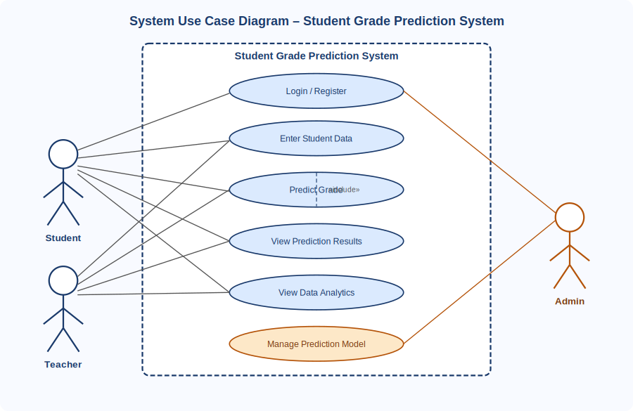
Figure 1: System Level Use Case Diagram

3.1. Use Case 1 – Login / Register
ID | UC001
Name | Login / Register
Description | This use case describes the process by which a new user registers for an account or an existing user logs in to gain access to the system.
Requirement(s) | FR001, FR002
Actor(s) | Student, Teacher, Administrator
Precondition | For registration: the user must not already have an account. For login: the user must be a registered member of the system.
Postcondition | The user is authenticated and redirected to their role-specific dashboard.
Basic Flow | Basic Flow  - User opens the application and is presented with the login page.  - For a new user: the user selects Register and fills in name, email, password, role, and phone number.  - System validates that the email is unique, the password meets the minimum requirement, and all fields are complete.  - On successful validation, the system creates the account and redirects the user to the login page with a success message.  - The user enters their email and password on the login page.  - System validates the credentials and creates an authenticated session.  - User is redirected to the role-specific dashboard.  Alternative Flow  - Administrator logs in to the admin panel and creates a new user account directly by entering the required details on behalf of the user.  Exceptions  - Invalid or duplicate email during registration: system displays a descriptive error message and highlights the problematic field.  - Incorrect credentials during login: system displays an authentication error without revealing which field is incorrect.

3.2. Use Case 2 – Enter Student Data
ID | UC002
Name | Enter Student Data
Description | This use case describes the process by which a student or teacher submits academic input data required for grade prediction.
Requirement(s) | FR003
Actor(s) | Student, Teacher
Precondition | The user must be authenticated and logged in to the system.
Postcondition | The student data is validated, stored in the system, and submitted to the grade prediction engine.
Basic Flow | Basic Flow  - User navigates to the data entry form from the dashboard.  - User enters the student name, attendance percentage, weekly study hours, and previous marks or GPA.  - System validates each field: attendance must be between 0 and 100, study hours must be a positive number, and previous marks must be within the valid range.  - On successful validation, the system stores the data and submits it to the prediction engine (UC003).  - System displays a confirmation message and triggers the prediction result view.  Alternative Flow  - A teacher enters data on behalf of multiple students by repeating the data entry form for each student.  Exceptions  - Out-of-range values or missing fields: system displays inline validation error messages and prevents submission until all fields are correctly completed.

3.3. Use Case 3 – Predict Grade
ID | UC003
Name | Predict Grade
Description | This use case describes the automated process by which the system applies the active machine learning model to submitted student data and generates a grade prediction.
Requirement(s) | FR003, FR004
Actor(s) | System (automated)
Precondition | Valid student data must have been submitted successfully through UC002.
Postcondition | A predicted grade and model confidence score are generated and stored, linked to the student record.
Basic Flow | Basic Flow  - System receives the validated student data from UC002.  - System loads the active pre-trained machine learning model from storage.  - The model processes the input features (attendance, study hours, previous marks) and computes the predicted grade.  - System stores the prediction result and confidence score linked to the student record.  - System triggers the result display view (UC004).  Alternative Flow  - No alternative flow. This use case is fully automated and system-driven.  Exceptions  - If the model file is missing or corrupted, the system displays a maintenance error message and notifies the administrator by logging the event.

3.4. Use Case 4 – View Prediction Results
ID | UC004
Name | View Prediction Results
Description | This use case describes the process by which a user views the grade prediction outcome along with contributing factor analysis and model accuracy information.
Requirement(s) | FR004, FR005
Actor(s) | Student, Teacher
Precondition | A grade prediction must have been successfully generated for the student through UC003.
Postcondition | The user has reviewed the predicted grade, confidence score, top contributing factors, and model accuracy.
Basic Flow | Basic Flow  - System displays the predicted final grade prominently on the results screen.  - System displays the model accuracy percentage to indicate the reliability of the prediction.  - System highlights the most influential input factors contributing to the predicted grade.  - User may choose to re-enter data for a new prediction or return to the dashboard.  Alternative Flow  - Teacher views prediction results for any student in their class by selecting the student from a class list.  Exceptions  - If no prediction exists for the selected student, the system displays a prompt directing the user to enter student data first.

3.5. Use Case 5 – View Data Analytics
ID | UC005
Name | View Data Analytics
Description | This use case describes the process by which a teacher or administrator views statistical visualizations and insights generated from stored student data.
Requirement(s) | FR006
Actor(s) | Teacher, Administrator
Precondition | At least one student data record and its prediction result must exist in the system.
Postcondition | The user has viewed the analytics dashboard including grade distribution, attendance correlation, and study hours analysis.
Basic Flow | Basic Flow  - User navigates to the Analytics dashboard from the main menu.  - System retrieves all stored student records and prediction results.  - System renders a grade distribution summary chart.  - System renders an attendance versus grade correlation chart.  - System renders a study hours versus grade analysis chart.  - User may apply optional filters such as date range or class section to refine the displayed data.  Alternative Flow  - Administrator views analytics across all classes and departments without filtering restrictions.  Exceptions  - If no student data records exist, the system displays an informational message prompting the user to enter student data before accessing analytics.

3.6. Use Case 6 – Manage Prediction Model
ID | UC006
Name | Manage Prediction Model
Description | This use case describes the process by which an administrator retrains or updates the machine learning prediction model using a new dataset.
Requirement(s) | FR007
Actor(s) | Administrator
Precondition | The administrator must be authenticated. A valid CSV dataset containing the required columns must be available for upload.
Postcondition | The updated model is trained, evaluated, saved, and deployed. New accuracy metrics are displayed in the system.
Basic Flow | Basic Flow  - Administrator navigates to the Model Management panel from the admin dashboard.  - Administrator uploads a new training dataset in CSV format.  - Administrator selects the desired machine learning algorithm: Linear Regression or Decision Tree.  - System validates the dataset structure, checking that required columns are present and data types are correct.  - System splits the data into training and test sets, retrains the model on the training set, and evaluates accuracy on the test set.  - The new model is saved to server storage and set as the active prediction model.  - System displays the new model accuracy metric on the admin dashboard.  Alternative Flow  - Administrator rolls back to the previous model version if the new model accuracy is below the acceptable threshold.  Exceptions  - Invalid dataset format or missing required columns: The system displays a descriptive error message with guidance on the expected CSV structure.  - Insufficient data rows for training: the system alerts the administrator that a minimum number of records is required.

Diagrams
The following activity diagrams illustrate the detailed flow of events for the main use cases of the Student Grade Prediction System. Figure 2 shows the complete grade prediction process from user login through data entry to result display. Figure 3 shows the login and registration process in detail.

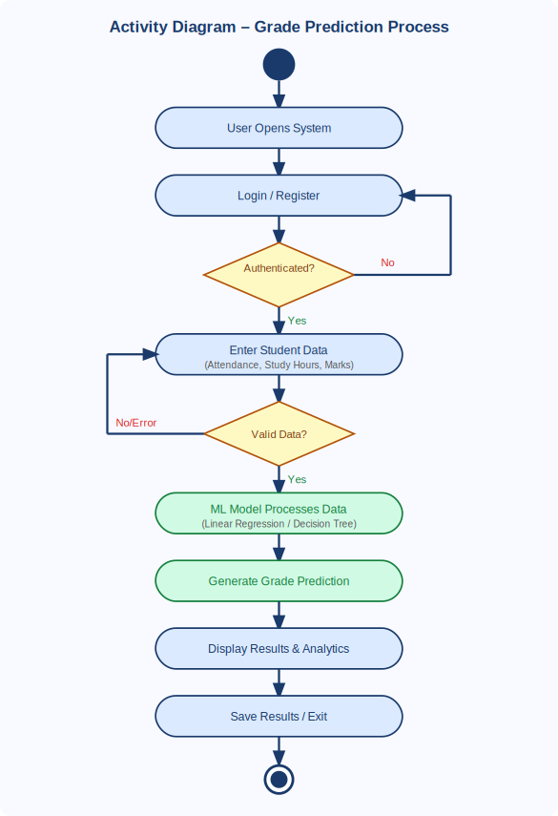
Figure 2: Activity Diagram – Grade Prediction Process

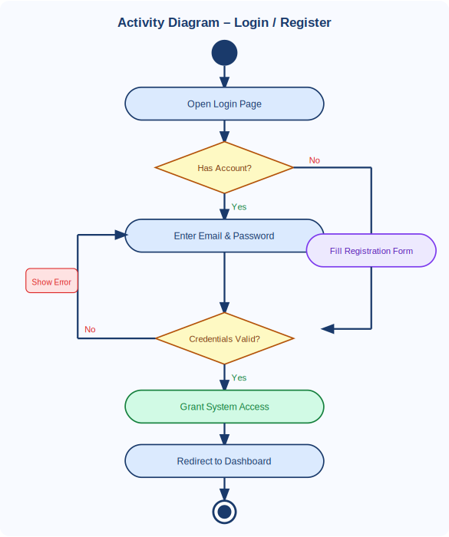
Figure 3: Activity Diagram – Login / Register Process

4. References
[1] Cortez, P., & Silva, A. M. G. (2008). Using data mining to predict secondary school student performance. In A. Brito & J. Teixeira (Eds.), Proceedings of the 5th Annual Future Business Technology Conference (pp. 5–12). Porto, Portugal.
[2] Hussain, S., Dahan, N. A., Ba-Alwi, F. M., & Ribata, N. (2018). Educational data mining and analysis of students' academic performance using WEKA. Indonesian Journal of Electrical Engineering and Computer Science, 9(2), 447–459.
[3] Kaggle. (2023). Students' performance in exams dataset. Retrieved from https://www.kaggle.com/datasets/spscientist/students-performance-in-exams
[4] Pedregosa, F., Varoquaux, G., Gramfort, A., Michel, V., Thirion, B., Grisel, O., … Duchesnay, E. (2011). Scikit-learn: Machine learning in Python. Journal of Machine Learning Research, 12, 2825–2830.
[5] Pressman, R. S., & Maxim, B. R. (2019). Software engineering: A practitioner's approach (9th ed.). McGraw-Hill Education.
[6] IEEE Computer Society. (1998). IEEE Std 830-1998: IEEE Recommended Practice for Software Requirements Specifications. IEEE.

